**Constructing an Interferometer with a Variable Beam Path Using a Translation Stage**

**Introduction**

The purpose of this experiment was to utilise wave interference phenomena to identify possible impacts on an interference pattern using a Michelson interferometer with an adjustable beam length and a Helium Neon (HeNe) laser.

Interferometry is a measurement method of wave interference utilising the principle of superposition. This principle states that when two (or more) waves cross at a point, the displacement of the point is the sum of the two waves displacement (Bryan & Hellemans, 2004, p. 695). Interferometers work with electromagnetic waves to measure the inference pattern, when the waves are at peak construction or deconstruction. The design relies on the symmetry of all elements, the superposition principal and nature of light waves to produce interference fringes visualised as dark spaces in projected light.

In this experiment we explored the impact of beam length

**Materials and Methods**

**Materials**

List the components used, including:

* Laser source
* Beam splitter
* Mirrors
* Adjustable translation stage
* Power meter
* Mounts, screws

**Setup Construction**

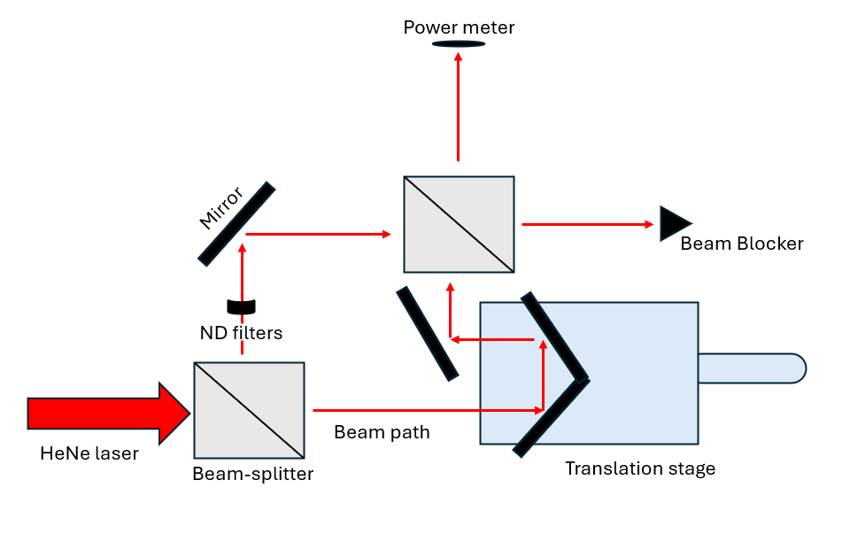

Figure . mach-Zender Beam splitter diagram slightly modified from: (ChaosFlaws, 2016)

**Alignment of Laser and Beam Splitter**: Describe initial alignment steps for splitting the laser into two beams.

1. **Mirror Positioning**: Detail the setup of mirrors to create two distinct beam paths.
2. **Incorporation of Translation Stage**: Explain how the adjustable translation stage was integrated into one path.
3. **Combining the Beams**: Discuss alignment to ensure the beams recombine at the detector.
4. **Detector Setup**: Describe setting up the power meter or other measurement tools.

**Challenges and Adjustments**

Provide space to document:

* Misalignments and how they were corrected.
* Steps that had to be redone due to unforeseen issues.
* Difficulties in achieving precise alignment of the optical components.

**Results and Observations**

**Interference Patterns**

* Detail the observed interference patterns as the stage is moved.
* Present measurements of power fluctuations between the two beams (graphs or tables).

**Sources of Fluctuation**

* Discuss factors contributing to measurement fluctuations, such as:
  + Environmental vibrations
  + Thermal effects
  + Imperfect alignment

**Discussion**

* Reflect on how changes in the path length (via the translation stage) influenced the interference pattern.
* Evaluate the sources of error and how they impacted the results.
* Suggest improvements to the setup or experimental method to minimize issues.

**Conclusion**

Summarize key takeaways, focusing on:

* How movement of the translation stage affected the construction and deconstruction of the interference pattern.
* Practical insights into maintaining stability and alignment in optical systems.
* The broader implications for using interferometers in precise measurements.

**References**

List any textbooks, research papers, or manuals consulted during the experiment.

**Bryan, B., & Hellemans, A. (2004).*The history of science and technology.* New York: Scientific Publishing Inc.**

**ChaosFlaws. (2016). Outcome of Mach-Zehnder interferometer experiment. Retrieved from https://physics.stackexchange.com/questions/274379/outcome-of-mach-zehnder-interferometer-experiment**

**Appendices (if applicable)**

* Include any raw data, detailed diagrams of the setup, or additional notes that support the main report.